**All data**

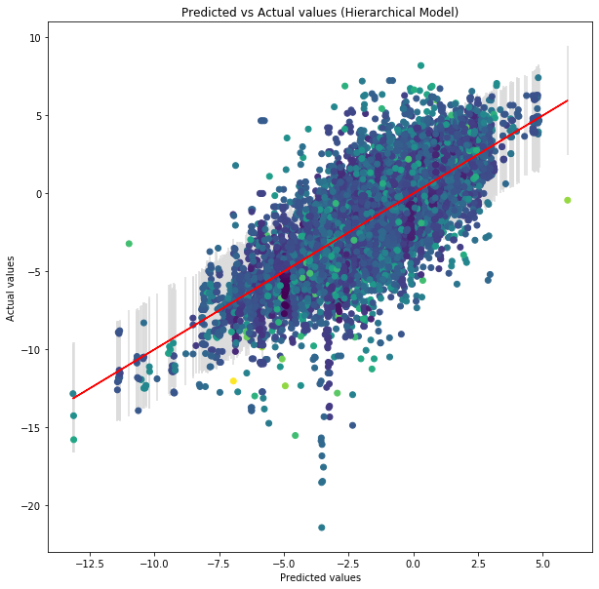

Computed from 4000 by 19939 log-likelihood matrix

Estimate SE

elpd_loo -41635.76 168.61

p_loo 1397.77 -

There has been a warning during the calculation. Please check the results.

------

Pareto k diagnostic values:

Count Pct.

(-Inf, 0.5] (good) 19407 97.3%

(0.5, 0.7] (ok) 452 2.3%

(0.7, 1] (bad) 78 0.4%

(1, Inf) (very bad) 2 0.0%

**No duplicates**

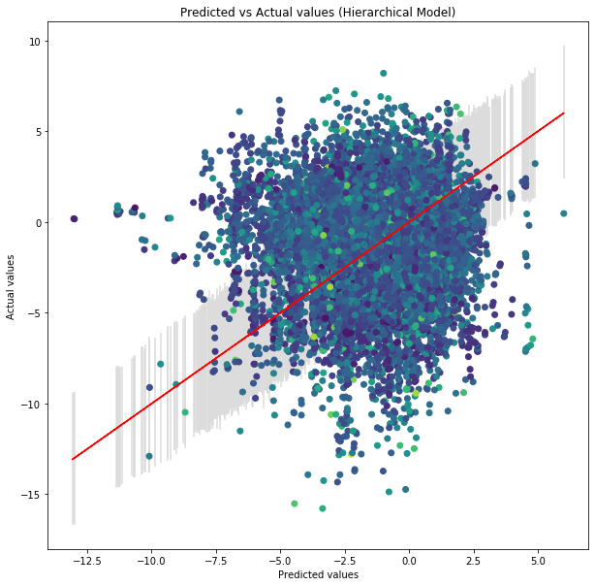

Pareto k diagnostic values:

Count Pct.

(-Inf, 0.5] (good) 15735 96.9%

(0.5, 0.7] (ok) 438 2.7%

(0.7, 1] (bad) 59 0.4%

(1, Inf) (very bad) 2 0.0%

**Less duplicates removed**

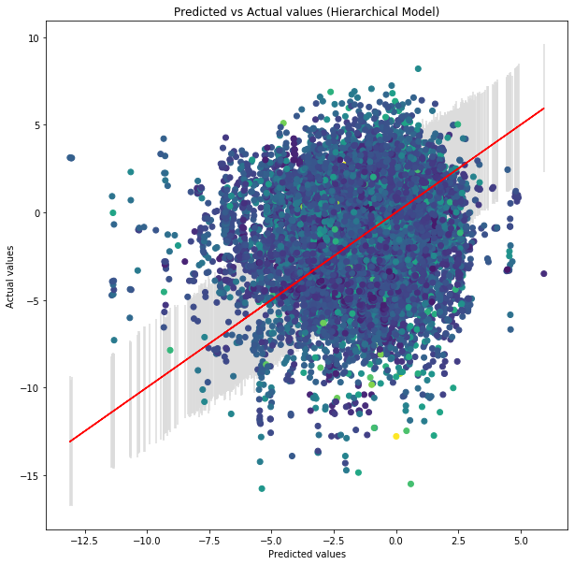

Computed from 4000 by 17087 log-likelihood matrix

Estimate SE

elpd_loo -36184.55 150.54

p_loo 1337.31 -

There has been a warning during the calculation. Please check the results.

------

Pareto k diagnostic values:

Count Pct.

(-Inf, 0.5] (good) 16578 97.0%

(0.5, 0.7] (ok) 439 2.6%

(0.7, 1] (bad) 67 0.4%

(1, Inf) (very bad) 3 0.0%

**New results with NANs**

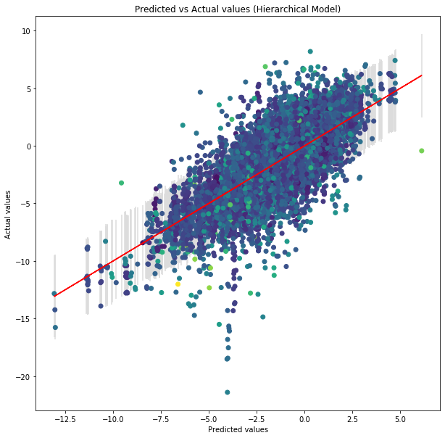

Computed from 4000 by 17087 log-likelihood matrix

Estimate SE

elpd_loo -36229.14 150.09

p_loo 1305.84 -

There has been a warning during the calculation. Please check the results.

------

Pareto k diagnostic values:

Count Pct.

(-Inf, 0.5] (good) 16610 97.2%

(0.5, 0.7] (ok) 414 2.4%

(0.7, 1] (bad) 59 0.3%

(1, Inf) (very bad) 4 0.0%

**New results with NANs rows in “species” removed**

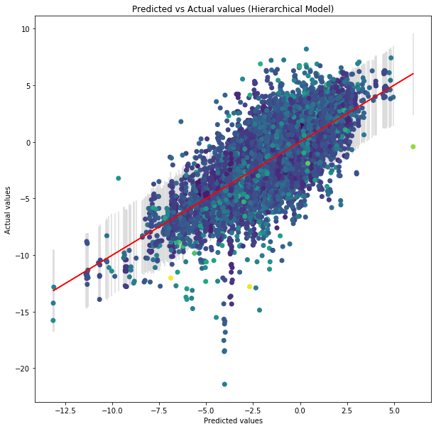

1 of 4000 (0.025%) transitions ended with a divergence.

These divergent transitions indicate that HMC is not fully able to explore the posterior distribution.

Try increasing adapt delta closer to 1.

If this doesn't remove all divergences, try to reparameterize the model.

Computed from 4000 by 16246 log-likelihood matrix

Estimate SE

elpd_loo -34430.85 147.38

p_loo 1273.77 -

There has been a warning during the calculation. Please check the results.

------

Pareto k diagnostic values:

Count Pct.

(-Inf, 0.5] (good) 15747 96.9%

(0.5, 0.7] (ok) 415 2.6%

(0.7, 1] (bad) 81 0.5%

(1, Inf) (very bad) 3 0.0%

**New results with any row containing NANs removed**

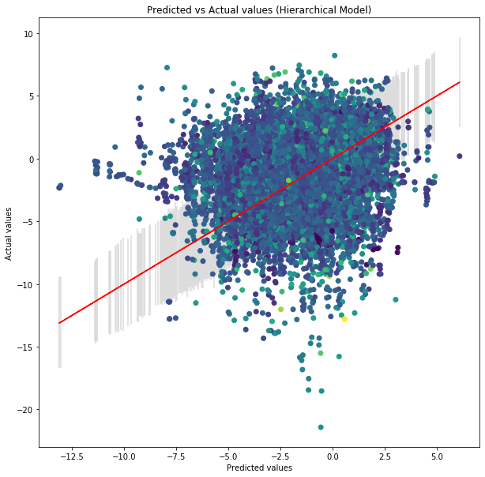

Computed from 4000 by 15879 log-likelihood matrix

Estimate SE

elpd_loo -33660.29 145.28

p_loo 1239.62 -

There has been a warning during the calculation. Please check the results.

------

Pareto k diagnostic values:

Count Pct.

(-Inf, 0.5] (good) 15386 96.9%

(0.5, 0.7] (ok) 429 2.7%

(0.7, 1] (bad) 62 0.4%

(1, Inf) (very bad) 2 0.0%

2 of 4000 (0.05%) transitions ended with a divergence.

These divergent transitions indicate that HMC is not fully able to explore the posterior distribution.

Try increasing adapt delta closer to 1.

If this doesn't remove all divergences, try to reparameterize the model.

**Substrates only**

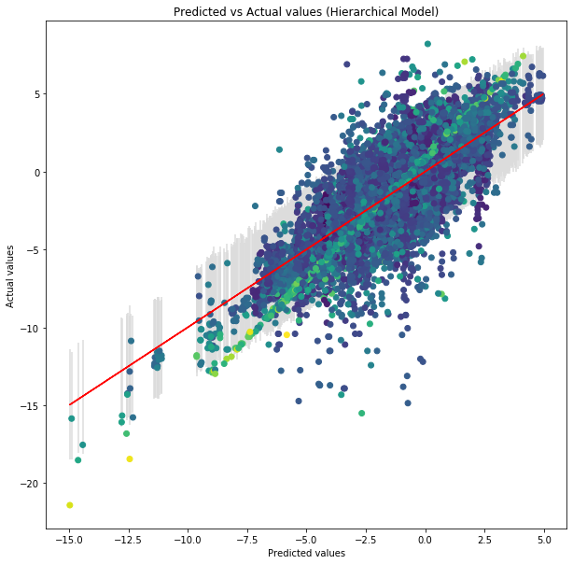

Computed from 1200 by 18460 log-likelihood matrix

Estimate SE

elpd_loo -39008.18 150.29

p_loo 2944.07 -

There has been a warning during the calculation. Please check the results.

------

Pareto k diagnostic values:

Count Pct.

(-Inf, 0.5] (good) 15204 82.4%

(0.5, 0.7] (ok) 1844 10.0%

(0.7, 1] (bad) 1251 6.8%

(1, Inf) (very bad) 161 0.9%

**Results after Teddy’s fix**

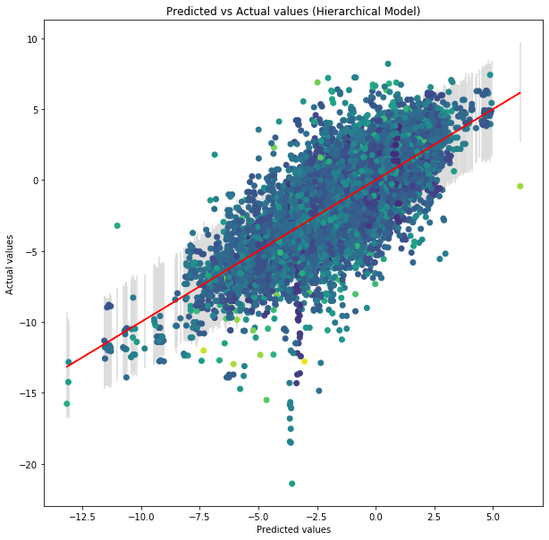

Computed from 800 by 18460 log-likelihood matrix

Estimate SE

elpd_loo -38491.19 162.61

p_loo 1263.85 -

There has been a warning during the calculation. Please check the results.

------

Pareto k diagnostic values:

Count Pct.

(-Inf, 0.5] (good) 17859 96.7%

(0.5, 0.7] (ok) 503 2.7%

(0.7, 1] (bad) 91 0.5%

(1, Inf) (very bad) 7 0.0%

**Results after Teddy’s fix+ substrates**

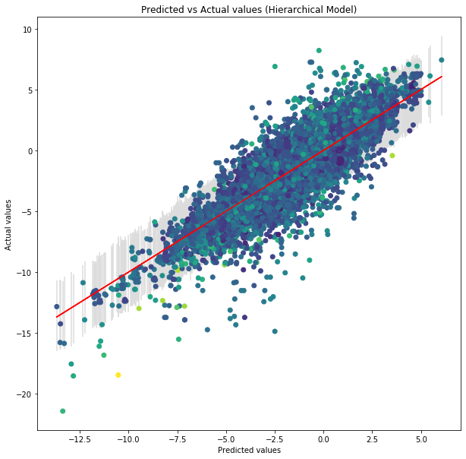

Computed from 800 by 18460 log-likelihood matrix

Estimate SE

elpd_loo -36002.21 159.40

p_loo 3492.16 -

There has been a warning during the calculation. Please check the results.

------

Pareto k diagnostic values:

Count Pct.

(-Inf, 0.5] (good) 15042 81.5%

(0.5, 0.7] (ok) 2335 12.6%

(0.7, 1] (bad) 962 5.2%

(1, Inf) (very bad) 121 0.7%

**Results substrates+ temperature**

Computed from 800 by 18460 log-likelihood matrix

Estimate SE

elpd_loo -35926.42 159.26

p_loo 3512.21 -

There has been a warning during the calculation. Please check the results.

------

Pareto k diagnostic values:

Count Pct.

(-Inf, 0.5] (good) 14916 80.8%

(0.5, 0.7] (ok) 2461 13.3%

(0.7, 1] (bad) 977 5.3%

(1, Inf) (very bad) 106 0.6%

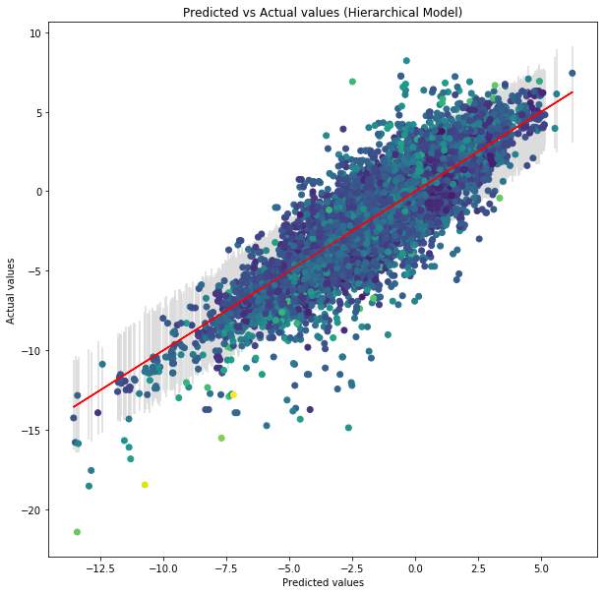

The following parameters had split R-hat greater than 1.1:

taufamily[1]

Such high values indicate incomplete mixing and biasedestimation.

You should consider regularizating your model with additional prior information or a more effective parameterization.

Checking sampler transitions for divergences.

3 of 800 (0.38%) transitions ended with a divergence.

These divergent transitions indicate that HMC is not fully able to explore the posterior distribution.

Try increasing adapt delta closer to 1.

If this doesn't remove all divergences, try to reparameterize the model.

**3000 iters**

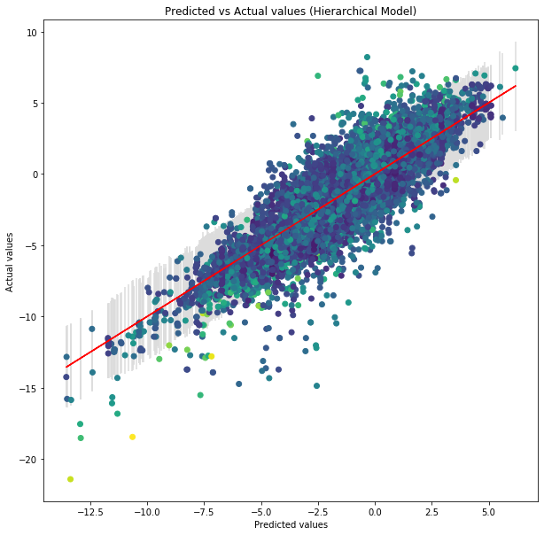

Estimate SE

elpd_loo -36104.13 161.83

p_loo 3689.22 -

There has been a warning during the calculation. Please check the results.

------

Pareto k diagnostic values:

Count Pct.

(-Inf, 0.5] (good) 15215 82.4%

(0.5, 0.7] (ok) 2506 13.6%

(0.7, 1] (bad) 706 3.8%

(1, Inf) (very bad) 33 0.2%

**Results temperature**

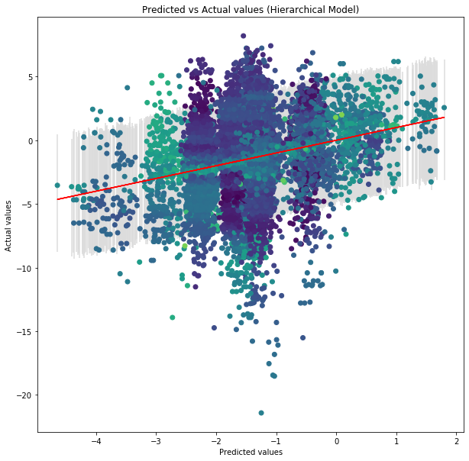

Computed from 800 by 18460 log-likelihood matrix

Estimate SE

elpd_loo -45305.79 123.53

p_loo 33.89 -

------

Pareto k diagnostic values:

Count Pct.

(-Inf, 0.5] (good) 18459 100.0%

(0.5, 0.7] (ok) 1 0.0%

(0.7, 1] (bad) 0 0.0%

(1, Inf) (very bad) 0 0.0%

**Results substrates+ temperature (continuous numbers)**

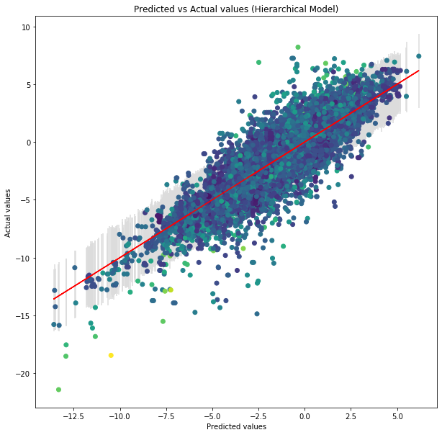

Computed from 1200 by 18460 log-likelihood matrix

Estimate SE

elpd_loo -35981.17 160.14

p_loo 3561.34 -

There has been a warning during the calculation. Please check the results.

------

Pareto k diagnostic values:

Count Pct.

(-Inf, 0.5] (good) 15127 81.9%

(0.5, 0.7] (ok) 2327 12.6%

(0.7, 1] (bad) 907 4.9%

(1, Inf) (very bad) 99 0.5%